CprE 381 – Computer Organization and

Assembly-Level Programming

Proj-B Report

Lab Partners _____________Muhamed Stilic_____________________

_____________Trevor Rowland_______________________

_____________Felipe Varela Carvalho______________

Section / Lab Time ______Section 1: 8:00am/9:40am______________

Submit a typeset pdf version of this on Canvas by the due date. Refer to the highlighted language in the Proj-B instructions for the context of the following questions.

- [Part 0] How are instruction and data memory initialized in the simulation? How does MARS interface with ModelSim?

Instruction and data memory are initialized in the simulation by a .as or a .asm to test the design with. MARS interfaces with ModelSim by compiling the instructions to test from before, then it will check to see if the vhdl of the processor will compile and compare to the MARS compilation for any mismatches. Once that is done, there will be a victory and generate all of the values within that .asm file. It will even show the whole wave form once it’s done compiling.

- [Part 0] In the MIPS skeleton VHDL, how is a halting / termination condition detected? What MIPS assembly instruction does this correspond to?

The halting/termination in the skeleton code by reading the inputs of the amount of instructions and then the instructions themselves, If the instruction that is detected is HALT then it will stop, otherwise it will take in the next coming instruction. The mips assembly instruction that is related to this condition is jr. The reason it should be jr is because it can return and stop the simulation in mips by jumping to an area where it wont work.

- [Part 1 (a)] Modify the provided spreadsheet to include the list of M instructions to be supported in this phase alongside their binary Instruction OPcodes and Funct fields, if applicable. Create a separate column for each binary bit. Inside this spreadsheet, create a new column for the N control signals needed in your single-cycle processor implementation. The end result should be an M*N table where each row corresponds to the output of the control logic module for a given instruction. [You can attach the spreadsheet as a separate file, with a single spreadsheet for all Phase I and Phase II instructions.]

*FILE IS IN FOLDER AS*

control_signals_template.xlsx

- [Part 1 (b)] Implement the control logic module using whatever method and coding style you prefer. Create a testbench to test this module individually, and show that your output matches the expected control signals from part 1a). [Please include waveforms and explanations.]

WAVEFORMS:
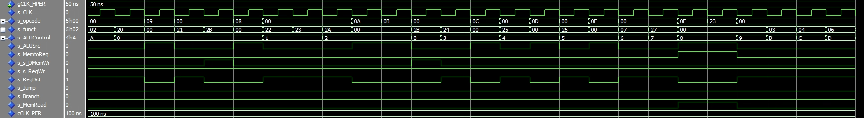
EXPLANATION:

This wave form shows how the control operates. When the control receives the opcode/funct from the IMem instructions. It will go through this control. This control will take apart the instructions and tell the what the signals should go out to the rest of the processor on what it should do. This wave form shows all of the phase 1 instructions. You can tell which ones are immediate due to the ALUsrc being 1. Only 1 mem to reg is lw. Sw is 1 to the s_s_DMemWr. The rest of the instructions basically have s_regDst 1 to make them go to where the bits need to in the ALU.

The control signals are the following: Jump, Branch, MemToReg, ALUOp, MemWrite, ALUSrc, RegWrite and isExtendSigned. Some of those signals are considered standard to the register. However, the team decided to add the “IsExtendSigned” signal since our sign extend has the option to extend either a signed or unsigned 16 bit bus. Other than that, the team followed the spreadsheet to decide which signals to set together with multiplexer commands such as “when else” to set the correct signals.

- [Part 2] In your writeup, provide your schematic for this part, describe what challenges (if any) you faced in implementing this module.

Schematic:
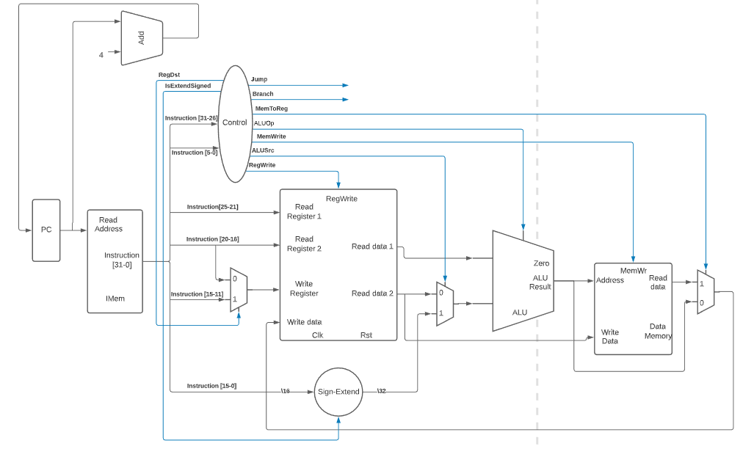

Challenges: The challenges were first to be overcoming the changes in our ALU/register to be combined into the processor given.

The team questioned the implementation on the register file for a long time. However, after further work, the team discovered that most of the bugs on the processor were related to the control logic module.

The spreadsheet was revised multiple times to fix bugs and compilation problems that indicated a mistake in the team’s VHDL documents.

The team had major problems with the load upper immediate function. By trying to implement this within the ALU and not add a new control signal, the team ended up taking a lot of time fine tuning the ALU to get this instruction working.

The team had a major bug caused by the register module. The register was not accurately responding to clock edges.

- [Part 4 (a)] Describe these possibilities as a function of the different control flow-related instructions.
Incrementing those new instructions to the processor adds another layer of complexity to control flow since the processor can now jump in between instructions and it can even use the stacker pointer to jump between functions. The register can also do conditional statements that change the control flow of the program. For example, beq will branch when the two compared numbers are equal, therefore, changing the control flow of the program.

This is directly related to the newly added control signals. These control signals are the responsible for enabling paths for data to flow through and be accesses at points in time that were previously inaccessible. Also, these control signals allow data to be saved in registers that can be latter accessed at later points in the code. This allows the processor to quite literally “jump around” the code and execute different functions in an more arbitrary way.

- [Part 4 (c)] Update your processor schematic for the instruction fetch logic and any other datapath modifications needed for control flow instructions. In your writeup, describe what additional control signals are needed.

The updated processor schematic. “PHASE 2”
FETCH LOGIC:

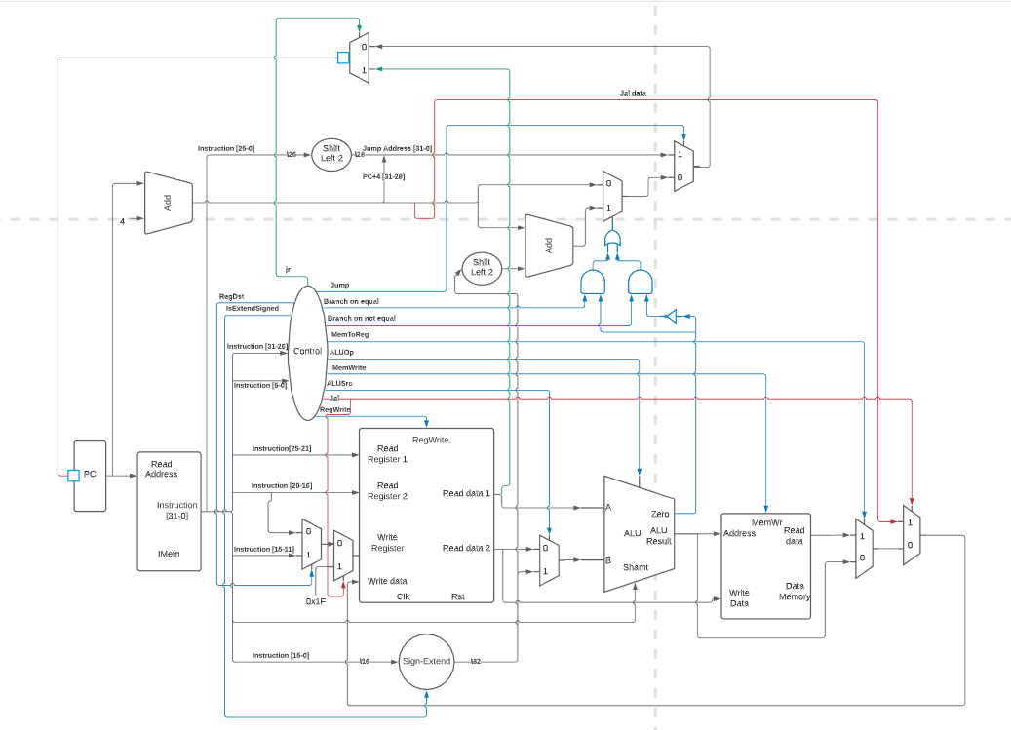
The newly added control signals are the following:
Jr: Handles jump register
Jump: Handles jump
Branch on Equal: Handles branch on equal
Branch on not Equal: Handles branch on not equal
Jal: Handles jump and link6
These new control signals handle all of the newly added instructions. It is possible to see that these control signals go to external multiplexers that directly influence the control flow of the processor.

- [Part 4 (d)] Include ModelSim waveforms, and describe how the execution of the control flow possibilities corresponds to the waveforms in your writeup.

“PHASE 2”
WAVEFORMS:

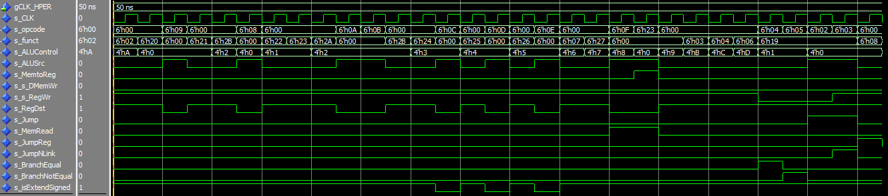

EXPLANATION:

The beginning of this test bench (which is testing the Control Logic Module block) is very similar to the previous one. The testbench compares incoming instructions (opcode and function) to a set of defined values (all listed in the control signal spread sheet). The only difference now is that the control logic module is being tested with the added signals. These added signals should be set to one given the correct commands, otherwise the processor does not function correctly.

The waveform attached above shows the correct output of the control logic module with all of the control signals being set at the correct times following the expected instructions.

- [Part 5 (a)] In your writeup, show the ModelSim output for the individual instruction tests, and provide a discussion of result correctness. It may be helpful to also annotate the waveforms directly.

WAVEFORMS Phase 1:

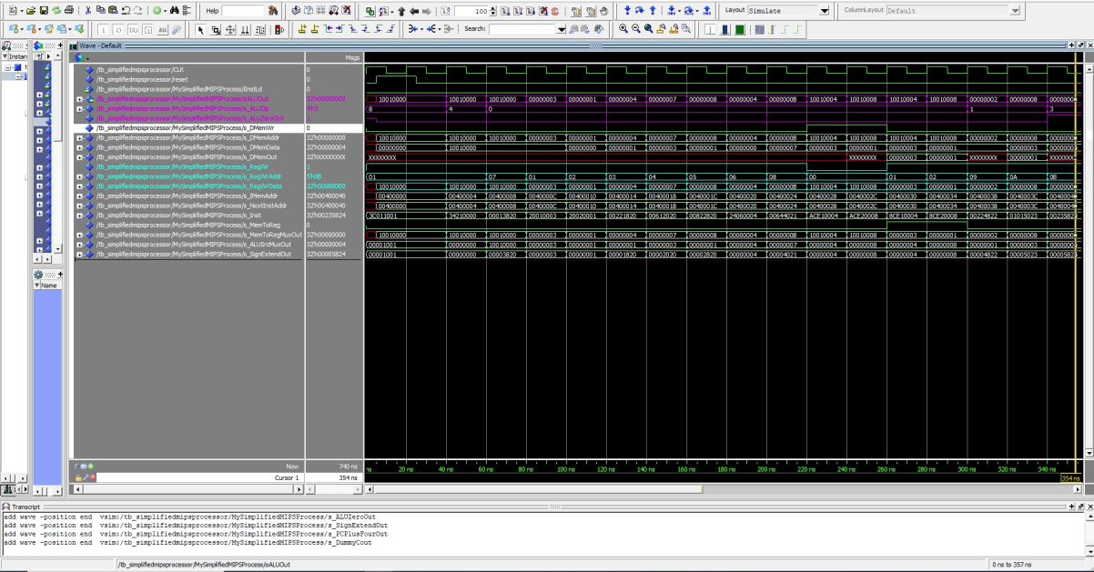
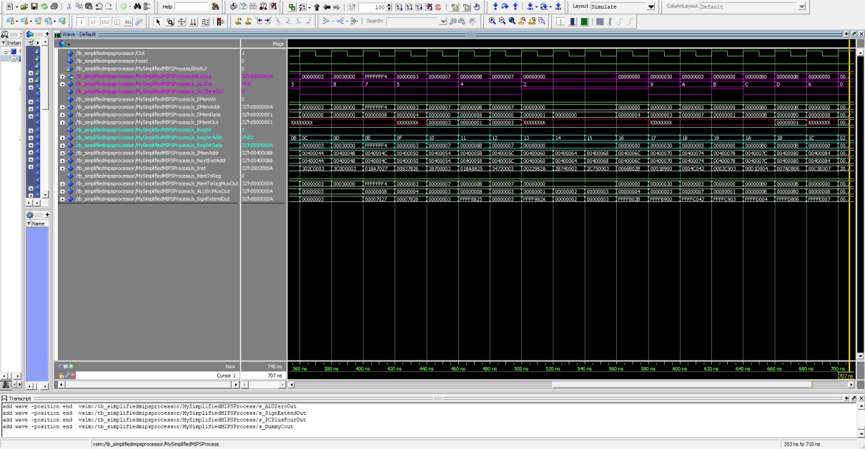

EXPLANATION:

This wave form shows the instructions add, addi, addiu, addu, and, andi, lui, lw, nor, xor, xori, or, ori, slt, slti, sltiu, sltu, sll, srl, sra, sllv, srlv, srav, sw, sub, and subu.

We clk, rst, alu, clm, pc

To keep this waveform concise and understandable, the team decided to only show the key signals involving the processor. Using these waves we can see that the ALU is outputting the correct results given all of the instructions in phase one. The team tried to include multiple edge cases, which include negative numbers and 32 bit calculations.
Overall, all of the instructions are correct and give expected outputs.

WAVEFORMS Phase 2:

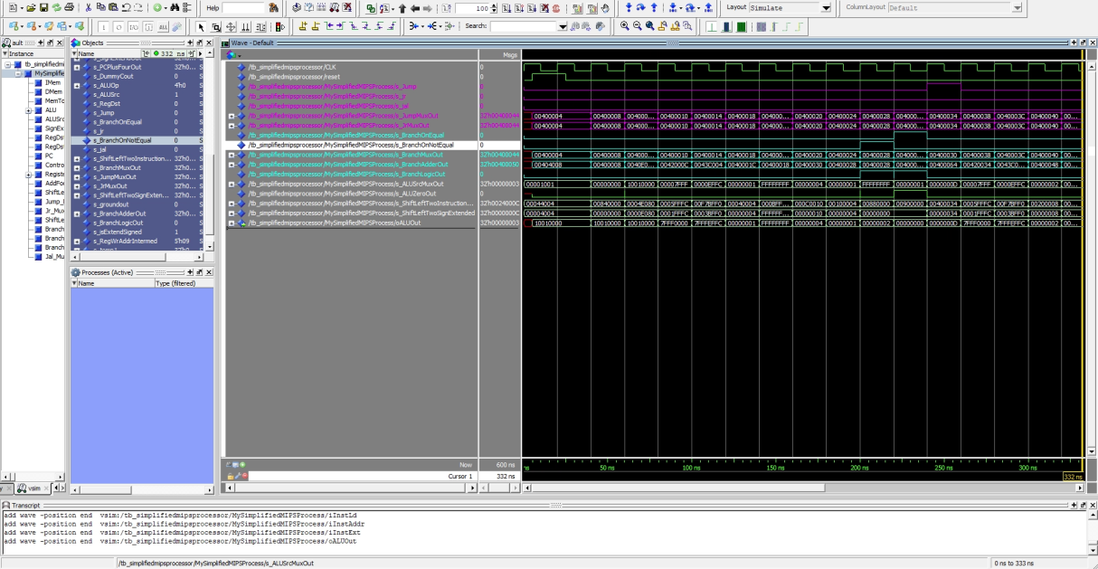

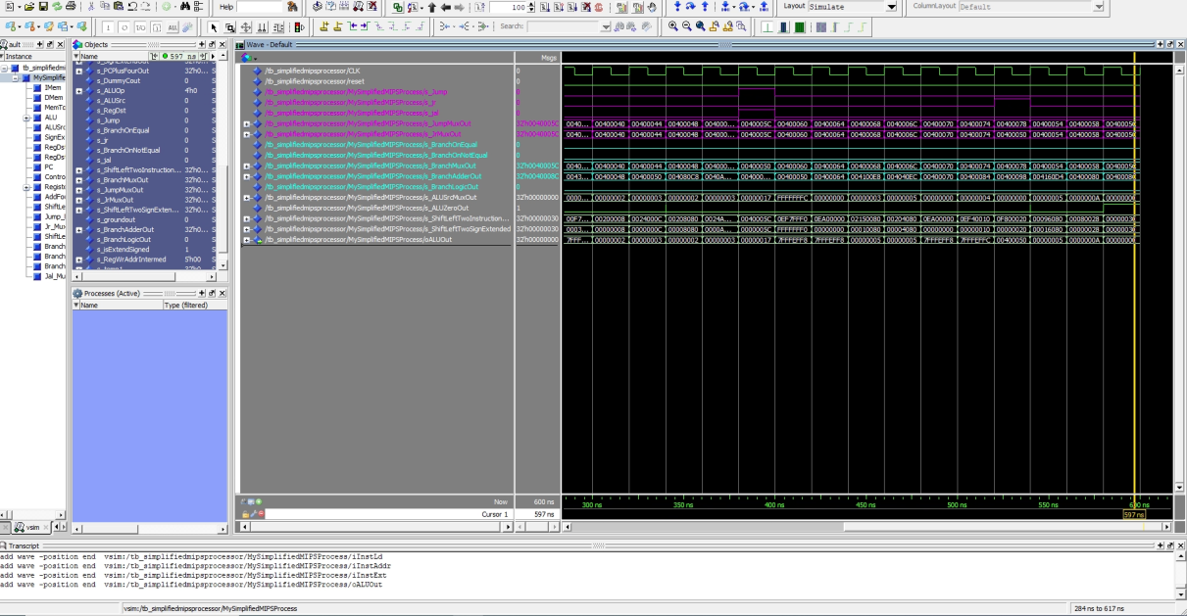
EXPLANATION:

This wave form shows the instructions beq, bne, j, jal, and jr.

Given that phase one is correct, all the team had to do at this point was to check the new control flow. Given the fact that the control flow runs in a different hardware path than the phase one flow, we do not need to show all of our signals to make sure that we are correct (the team fully debugged this part, however, due to the sake of making grading easier, we are only showing the needed signals).

Given the wave forms above, the team correctly implemented the new instructions and the new branch and jump instructions follow the expected pattern. It is possible to see that by following the opcode and the function across the code and see how they directly influence the control logic module.

- [Part 5 (b)] In your writeup, show the ModelSim output for the Bubblesort test, and provide a discussion of result correctness. It may be helpful to also annotate the waveforms directly.

WAVEFORMS:
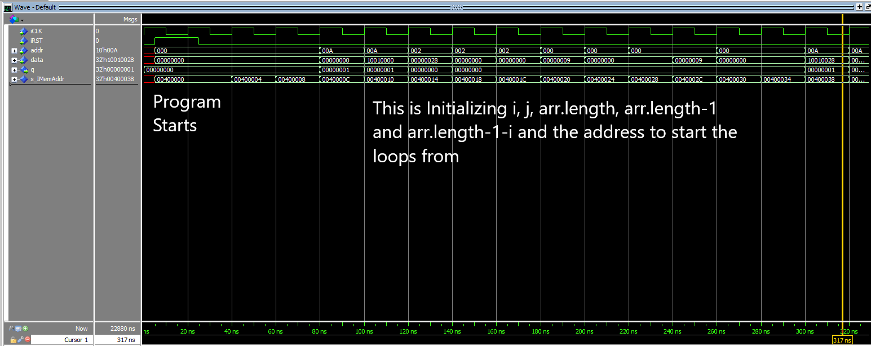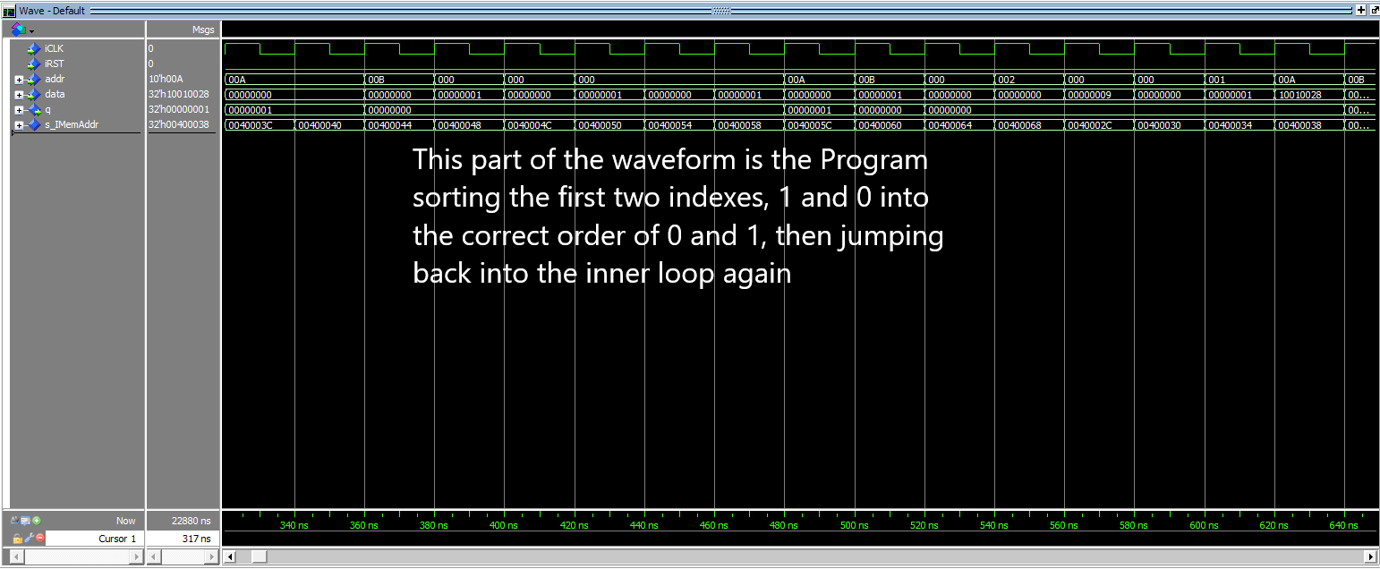
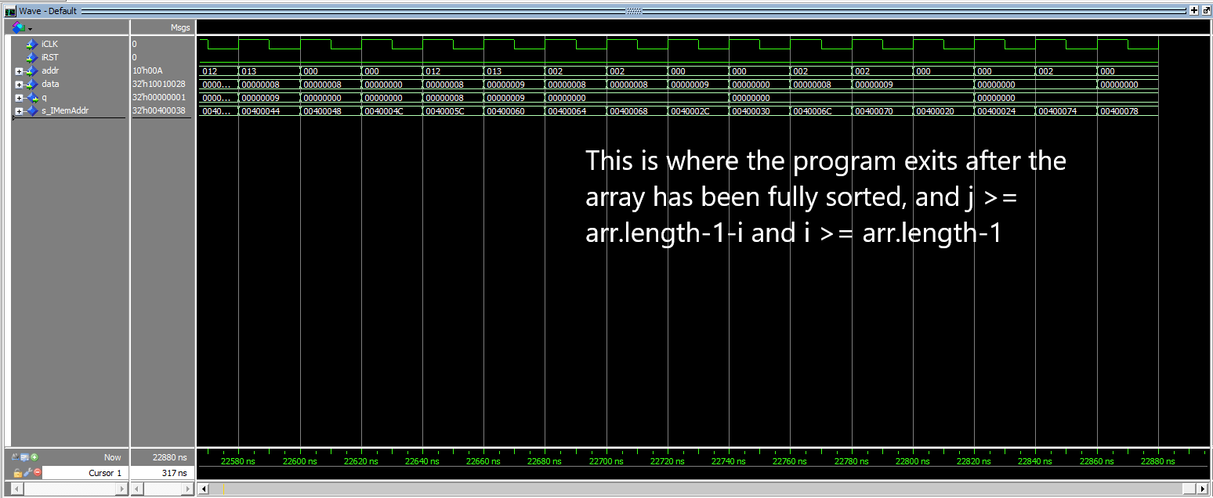
EXPLANATION:

This wave form shows the BubbleSort method working, the first screenshot shows the initialization of the array’s length, the iterators i and j for the loops for the sorting method, and the address of the array’s 0th index. The second shows the words being loaded into DMem, the sort occurs, and they are Stored from the output of DMem back into Memory and the process repeats for the rest of the Array. After the array is fully sorted, the program checks through the bge and ble conditionals in the BubbleSort MIPS Code, and finally exits the program.

- [Part 5 (c) BONUS] In your writeup, show the ModelSim output for the Mergesort test, and provide a discussion of result correctness. It may be helpful to also annotate the waveforms directly.

We skipped Merge Sort. It’s a bonus.

- [Part 7] Report the maximum frequency your processor can run at and determine what your critical path is. Draw this critical path on top of your top-level schematic. In your writeup, briefly discuss your critical path results. What components would you focus on to improve the frequency?

Max Frequency: 17Mhz

Critical Path: LUI
Total Path: PC -> s_IMemAddr -> IMem -> RegisterFile -> ALUSrc -> ALU -> ALUBarrel -> ALUBarrelShifter -> ALUData_OUT -> DMem

We concluded that because of the way this data path is shown in the timming.txt. It looks like the critical path is the LUI instruction.

The components I would focus on to improve frequency would be any design that includes a clock and the ALU as it’s the one that takes the most amount of time.

The critical path design:

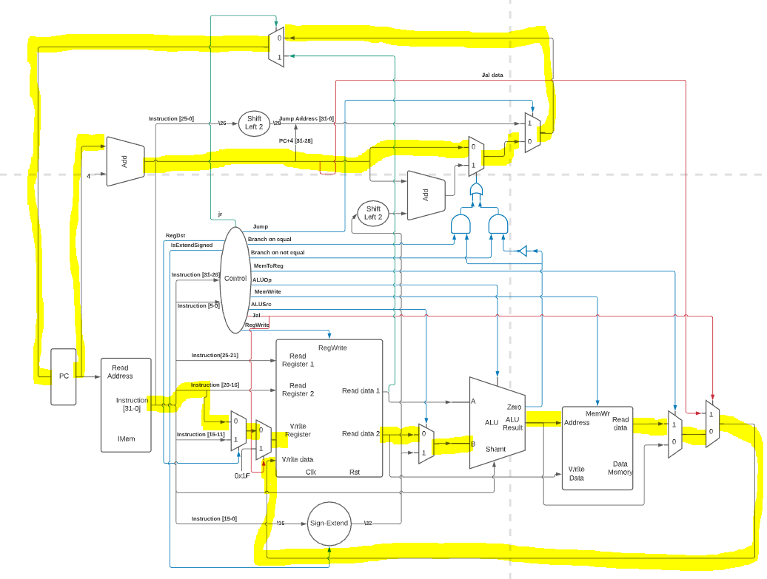

- [Feedback] You must complete this section for your lab to be graded. Please complete each column separately for each team member; I expect it to take roughly 10 minutes (do not take more than 20 minutes).

  - How many hours did you spend on this lab?

Task | During lab time |  |  | Outside of lab time
Team Initials | MS | TR | FC | MS | TR | FC
Reading lab | 2 |  | 2 | 1 | 2 | 6
Pencil/paper design |  | 2 |  | 1 | 0 | 3
VHDL design | 6 |  | 5 | 17 | 20 | 24
Assembly coding |  |  | 1 | 7 | 15 | 5
Simulation |  |  |  | 16 | 0 | 10
Debugging |  | 4 |  | 10 | 16 | 5
Report writing |  |  |  | 2 | 2 | 2
Other: |  |  |  | 0 | 0 | 0
Total | 8 | 8 | 8 | 54 | 55 | 57

  - If you could change one thing about the lab experience, what would it be? Why?

Muhamed:
Having more time with Tas would be very helpful. Even though the accessibility with Tas was better through Discord, some TAs were overwhelmed with question .

Trevor:
More TA help ours would be appreciated. Even if it is a quick Direct Message on Discord. A better review of MIPS would be very helpful, specially for test cases and Bubble Sort.

Felipe:
The lab report. I believe writing this lab report was not as efficient as doing the project. Time spent writing the lab report could have been spent doing the lab and preparing a better set of documents to submit to the graders.

  - What was the most interesting part of the lab?

Muhamed:
Actually putting everything together and seeing the gears turn.

Trevor:
Even though it was hard to program, bubble sort was an interesting challenge. Debugging test cases was also very fun.

Felipe:
The fact that we actually built a functioning 17Mhz processor is something to be very proud of.

